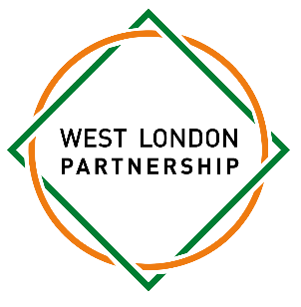
Dear Parent/Carer,
We are pleased to inform you that your child has been invited to become/remain a representative on the West London Partnership Student Council for the upcoming academic year.
This is a fantastic opportunity for your child to develop leadership skills, work collaboratively with students from across the partnership, and play an active role in shaping the future direction of the West London Partnership. The student council is made up of representatives from all 11 schools within the partnership and aims to foster student voice, leadership, and community engagement.
As part of their involvement, your child will be expected to attend:
- Two after-school meetings per term
- A Christmas Quiz event
- WLP Talent Show

Each meeting will be held at one of the partnership schools, and the full schedule of dates and venues is provided below.
To confirm your child’s place on the council, we kindly ask that you complete the online parental consent form. Deadline: Friday 19th September

Meeting & Event Schedule
- Tuesday 30th September, 4.30pm – 6.00pm – St Paul’s Girls’ School
- Thursday 6th November, 4.30pm – 6.00pm – TBC
- Christmas Quiz: Tuesday 8th December, 4.30 -6.30pm – St Paul’s Girls’ School
- Tuesday 20th January, 4.30pm – 6.00pm – TBC
- Thursday 26th March, 4.30pm – 6.00pm – TBC
- Wednesday 29th April, 4.30pm – 6.00pm – TBC
- Wednesday 10th June, 4.30pm – 6.00pm – TBC
*Meetings will take place at WLP schools, once confirmed you will be informed.

(Attendance is expected at all meetings however we understand that students may occasionally have other commitments)

Thank you for your continued support. We are excited to see the contributions your child will make this year as part of the West London Partnership Student Council.
If you have any questions or require further information, please do not hesitate to get in touch.
Yours sincerely,
Rachel Mcglinchey
West London Partnership Coordinator
rachel.mcglinchey@spgs.org

