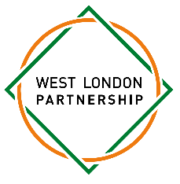

Dear parent/carer,

As a member of the West London Partnership (WLP) your child is being invited to take part in the annual WLP Y9 Christmas Quiz.
Date: Tuesday 9th December
Time: 4.45pm – 6.30pm
Location: St Paul’s Girls’ School
This is a fun event designed to get students from our partner schools together to build teamwork and engage in some friendly rivalry.
On arrival at St Paul’s Girls’ School students will be placed into mixed teams where they will have to choose a team name and make festive hats as an ice breaker. This will be followed by the main event of the quiz.
The quiz this year is being delivered by Quizmaster Will who will test students’ knowledge! The WLP Student Council will also be present to deliver the quiz and support the quiz teams. There will be refreshments and snacks throughout the evening.
The winning team will be presented with the WLP Trophy.
Students will need to make their own way to and from the Quiz venue. Students will be dismissed at 6.30pm. Please indicate in the consent form if your child is free to go home by themselves or if they will be collected.
Please note that during the event we will be taking photos and video footage for a WLP promotional video. If you prefer that your child is not filmed or photographed, please indicate this in the consent form.
If you need to contact your daughter in an emergency, please telephone the school reception on 020 7603 2288 and they will be able to contact the relevant member of staff.
If your child has a medical condition which requires an inhaler or epi-pen they must bring their own as we do not have these available for visiting students.
Please complete the online consent form which can be found here, the deadline to complete this is Friday 28 November.
For more details, please contact me at rachel.mcglinchey@spgs.org
Best wishes,
Rachel Mcglinchey
West London Partnership

