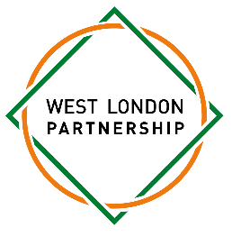
Dear Parents/Guardians,
We are pleased to invite your child to join the St Paul’s Girls’ School Mandarin HSK Course.
The course will be delivered by our Lead Teacher of Mandarin with the help of SPGS students studying IGCSE Mandarin. SPGS will provide textbooks and workbooks for all participating students. Students will be expected to complete practice assignments in their own time between sessions in order to make progress towards the HSK qualification.
You can find out more about the HSK qualifications here HSK (Chinese proficiency test) | Confucius Institute 曼彻斯 特大学孔子学院 | The University of Manchester.
Venue: St Paul’s Girls’ School, Brook Green. London W6 7BS.
Students should come to the Rosalind Franklin Wing visitor entrance at the front of the school where a member of SPGS staff will meet them.
Dates: Wednesday 24th September – Wednesday 23rd June (a full list of dates and details can be found in the accompanying Information Sheet)
Times: 4.10pm – 5.30pm
To ensure your child’s participation, we kindly ask that you complete and return the online Parental Consent Form by Friday 31st October. This will allow us to finalize enrolment and make sure all students have permission to take part by the start date.
We’re excited about the benefits this course will bring to your child’s learning experience, and we hope they’ll take advantage of this unique opportunity!
If you have any questions or need further information, please do not hesitate to contact us at wlp@spgs.org
Thank you for your support, and we look forward to welcoming your child back to the Mandarin HSK Course!
Warm regards,
Rachel Mcglinchey
West London Partnership Coordinator

West London Partnership Schools: St Paul’s Girl’s School, St Paul’s School, Sacred Heart High School, Phoenix Academy, Putney High School, Latymer Upper School, Hammersmith Academy, Fulham Cross Girls’ School, Fulham Boys School, Christ’s School, Cardinal Vaughan Memorial School

